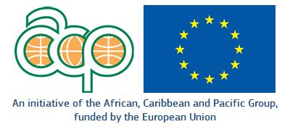

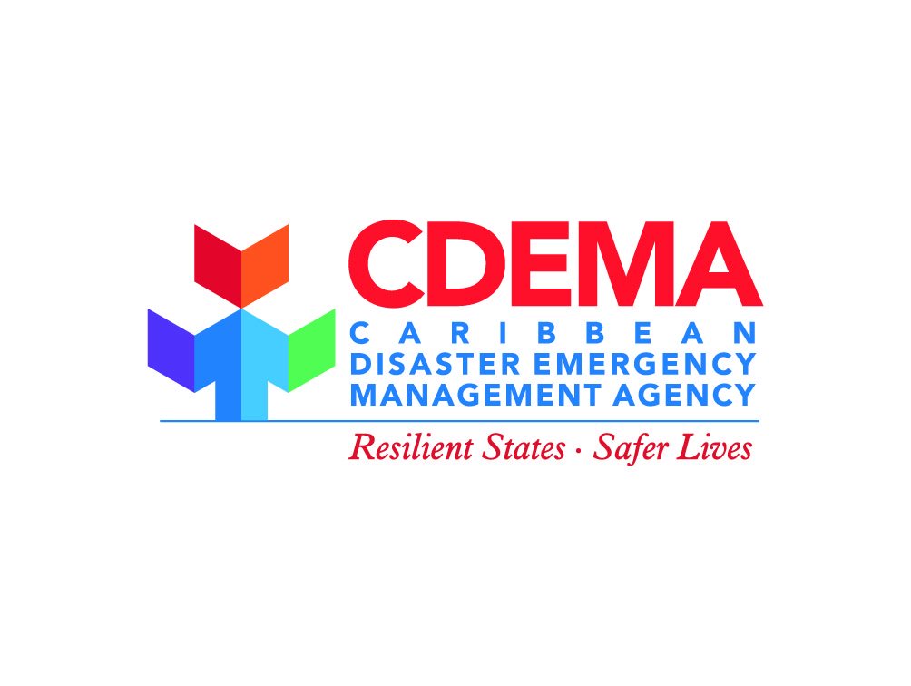

|  |
| --- |
| COUNTRY DIRECTED FUND **guidElines FOR applicants** |

**March 1st, 2016**

**Intra ACP Disaster Risk Management in CARIFORUM Programme**

**CDEMA**

**Resilience Way, Lower Estate**

**St. Michael, Barbados**

# Overview of the Country Directed Fund

The Country Directed Fund (CDF) mechanism was established in 2009 under the Comprehensive Disaster Management Harmonized Implementation Programme: Phase 1 (CDM HIP), to support the urgent need expressed by National Disaster Offices (NDOs) to access funds to strengthen their ability to achieve tangible CDM results where national budgets were insufficient. With financial support from the Department of Foreign Affairs, Trade and Development of Canada (formerly CIDA), UK Aid from the Department for International Development (DFID) and the Department of Foreign Affairs and Trade (formerly AusAID), eighteen (18) CDEMA PS benefitted from the CDF grant mechanism.

Through the **European Commission funded, Strengthening of the Capacity of the CDEMA Coordinating Unit and Participating States for Implementation of Comprehensive Disaster Management project**, funding has been provided to allow the CDEMA CU to continue to provide its Eligible Participating States with financial support through the Country Directed Fund mechanism. The CDF arrangements were therefore enhanced based on internal and external reviews including the CDM HIP Evaluation to build upon previous successes, strengthen the process and position the facility for future growth.

With its emphasis on providing quality country centered programming support; the CDEMA CU will implement the Country Directed Fund (CDF) with a view to strengthening the foundation that has been laid for transforming the CDF into a grant mechanism that meets international standards.

The CDF grant facility will be implemented from September 2014 to August 2019.

# COUNTRY DIRECTED FUND ELIGIBILITY[1] CRITERIA

**2.1 Grant Description**

The Country Directed Fund consists of two grants, differentiated based on the amount of the grant being applied for. The grants are categorized and described below, amounts of:

* 1. up to Euro 10,000.00 and
  2. in excess of Euro 10,000.00 up to a maximum of Euro 60,000.00.

**2.1.1 Grants of amounts up to Euro 10,000**

1. A **responsive Simplified process** will be used for access to a maximum of €10,000. Applications for amounts under Euro 10,000.00 will also be accepted and processed on an ongoing basis. **Applications related to this process can be submitted at any time of the year and not in response to the Call for Proposals.**
2. Administration of the Small CDF grant up to a maximum of Euro 10,000.00 will be in support of the following prioritised areas:
3. Priority country capacity building areas within the CDEMA Corporate Plan;
4. Training and capacity building of senior officials through the CDEMA CU;
5. Technical assistance through the TASP;
6. Participation of National Disaster Coordinators in the governance meetings of the organs of the CDEMA CU and the CDM Conference;
7. National level training initiatives, including ME&R, response coordination.

And also the following:

1. Strategic Planning, M&E and Research;
2. Contingency planning and exercise design and testing;
3. Emergency Response Coordination;
4. Disaster Situational Awareness (Damage Assessment);
5. Information Management;
6. Disaster Risk Reduction;
7. National Disaster Management Organization Capacity Building;
8. Information and Communication Technology;
9. Enhanced institutional capacity;
10. Knowledge management and learning for CDM;
11. Sector integration of CDM
12. Enhanced community resilience
13. Grants up to a maximum of Euro 10,000.00 will be considered for approval by **CDEMA’s Internal Grant Approval Committee**.

**2.1.2 Grants of amounts in excess of Euro 10,000 up to a maximum of**

**Euro 60,000**

1. A **competitive Call for Proposals** will be used to access amounts in excess of Euro 10,000.00 and up to a maximum of Euro 60,000.00. The call for the submission of applications will be done twice per annum on March 1st and September 1st of each year and will close at a minimum on April 15th and October 15th respectively. In instances where these days do not fall on regular working days of the CDEMA CU, the call will be made on the first working day immediately following.
2. Grants of Euro 10,000 up to a maximum Euro 60,000 will be in support of the following prioritized areas:
   * + 1. Enhanced institutional capacity;
3. Knowledge management and learning for CDM;
4. Sector integration of CDM;
5. Enhanced community resilience.
6. Strategic Planning, M&E and Research;
7. Contingency planning and exercise design and testing;
8. Emergency Response Coordination;
9. Disaster Situational Awareness (Damage Assessment);
10. Information Management;
11. Disaster Risk Reduction;
12. National Disaster Management Organization Capacity Building;
13. Information and Communication Technology.

.

1. The identified intervention(s) must be completed within nine (9) months of disbursement of the funds.
2. Applicants may apply for funding utilising the Application Form available. Instructions on how to complete the application form is attached as Appendix 1.
3. Applications must be submitted to the Executive Director, Caribbean Disaster Emergency Management Agency (CDEMA) Coordinating Unit ([cdema.cdf@cdema.org](mailto:cdema.cdf@cdema.org)) or CDEMA Coordinating Unit, Resilience Way, Lower Estate, St. Michael, Barbados no later than **15th April**, **2016** **at 11:59 p.m. Eastern Standard Time**.
4. The **CDF Grant Approval Board** will be responsible for approving the amounts in excess of Euro 10,000.00 up to a maximum of Euro 60,000.00.
5. Proposals will be screened for eligibility, completeness and linkages to the CDM strategy 2014-2024 and eligible Participating State’s country work programme before being submitted to the Grant Approval Board who will review the application and make the final decision for granting the funds.
   1. **Results**
6. Applications for funding must support the CDM results articulated in the Country Work Programme that have been endorsed by the **requisite governmental authority and accepted by CDEMA CU as the final CWP**.
7. Applications should clearly specify the outputs and subsequent outcome of the initiative (i.e. what will change).
8. Measurement of progress towards the achievement of the outputs and outcomes should be clearly described in terms of indicators which have baselines, milestones and a final target.
9. Applicants must demonstrate how results achieved will be sustained at the end of the project.
   1. **Reporting**
10. Results based reporting must utilize the indicators developed in the PMF for each project. Reports must also be in-keeping with the requirements for reporting as stipulated in the Letter of Agreement and should at a minimum focus on the following:
    1. Outcome of the initiative highlighting what has changed;
    2. Problems encountered and how they were addressed;
    3. Lessons learned;
    4. Evaluation of the initiative by main beneficiaries and participants;
    5. Sustainability plan;
    6. Visibility component of the project;
    7. Financial report to include full accounting for all expenditure received and copies of invoices and receipts.
11. Reports of all previously CDF supported initiative MUST be submitted to and accepted by the CDEMA CU. However on a case by case basis, the CDEMA CU will give consideration to approving new initiatives where PSs have expended 90% of the previously approved CDF budget and submitted a report.
    1. **Eligible Expenditures**
12. The CDF will not be used to meet recurring organisational expenses.
13. Support of other national CDM partners must be consistent with the CDM agenda articulated in the endorsed Country Work Programmes. The CDF however should not be used to meet the **core** responsibilities of other agencies.
14. Capital expenditure should NOT exceed 20% of the application budget. The following capital goods are restricted items and may not be purchased through CDF funds- vehicles, computers, tablets, smart phones and television monitors.
15. The CDEMA CU can give consideration to applications which exceed 20% capital expenditure or include the restricted capital items listed above, if the initiative will contribute directly to reducing vulnerability at the community level (e.g. hazard mitigation and Early Warning Systems).
16. Applicants may not receive more than one grant for the same action.
17. The CDF will not be awarded cumulatively or retrospectively.

**2.5 THE APPLICATION**

**2.5.1 General Information**

1. The application must explain and provide evidence of why the intervention is necessary. It should include a statement as to why national budgets or technical resources are insufficient.
2. The activities supported in the application must be directly linked to the Eligible Participating State’s **approved Country Work Programme**.
3. The application should set out who will benefit and why they are target beneficiaries, demonstrating how gender considerations will be addressed.
4. Proposed projects should not have a detrimental impact on the natural or social environments.
5. The application should be accompanied by a clear work plan showing a detailed schedule of activities, a detailed indicative budget and a performance monitoring framework.
6. Applicants should clearly identify the risks to the successful implementation of the project and outline how these will be addressed.
7. Applicants are responsible for conducting effective due diligence for service providers, vendors and implementing partners for CDF supported initiatives. CDF grant applications should not reflect any artificial separation of contracts.
8. Applicants must demonstrate the ability to utilize the funds applied for within the stipulated timeframe of six months and no later than nine (9) months from approval of the application and signature of the Letter of Agreement.
9. The budget should be broken down into different elements; e.g. salaries, travel equipment and supplies, training, and accommodation, administration, monitoring and evaluation etc. In-kind contribution and/or co-financing where applicable should be included.
10. Applicants may submit a ***maximum of two applications*** per eligible Participating State per call, not exceeding Euro 60,000.00 in total per annum.

**2.5.2 The Application Process**

1. All applications are to be submitted to the Office of the Executive Director of the CDEMA CU (cdema.cdf@cdema.org) by closing dates in **April** and **October o**f each year; for the **THIRD Call** by 15**th April, 2016** **at 11:59 p.m. Eastern Standard Time**. The CDEMA CU will undertake an initial review of each application to determine whether it has met the criteria for submission to the CDF Grant Approval Board.
2. Every Call for Proposals will be accompanied by guidelines for applicants. The guidelines for applicants will be published on the CDEMA website ([www.cdema.org](http://www.cdema.org)) and in any other appropriate media (other websites including the EU website, specialised press, local publications, etc.). They will also be available in hard copy from the CDEMA CU.
3. At the latest 21 days before the deadline for submission of the proposal, one or more information sessions will be conducted, this will be accessible by potential applicants. Such information sessions will be held and the presentation/documentation delivered during the session will be available on CDEMA website and shared for upload on websites where the call was published.
4. Applicants will be able to ask questions to help them fill in the form and put together their applications. Questions, in writing, may be submitted up to 21 days before the deadline. The Senior Programme Officer (OED) will be the point of contact (cdema.cdf@cdema.org) for all questions related to completing the application. Responses to all questions will be made public and accessible to all applicants at least 11 days before the deadline for submission of proposals. (In the interest of equal treatment of applicants, the CDEMA CU will not give a prior opinion on the eligibility of an applicant(s), an affiliated entity (ies), an action or specific activities.)
5. Within **one week** of submission of applications, the CDEMA CU will inform applicants whether applications have met the criteria for submission to the Approval Committee or Board. In cases where the criteria has not been met, applicants are free to resubmit applications if within the stipulated timeframe for submission of applications.
6. Any attempt by an applicant to influence the process in any way (whether by making contact with members of the evaluation committee or otherwise) will result in the immediate exclusion of its proposal from further consideration.
7. Suitable applications received at any time during the year and up to a maximum of Euro 10,000.00 will be forwarded to CDEMA’s Internal Grant Approval Committee for approval; Suitable applications for amounts in excess of Euro 10,000.00 and up to a maximum of Euro 60,000.00 will be submitted by the CDEMA CU to the CDF Grant Approval Board
8. Applicants, whose applications have successfully reached the stage of review by the relevant approval body, will be informed of the final decision on the award of the grant by **May 31st**and **November 30th** of each year.
9. The CDEMA CU will from time to time, in collaboration with grant recipients conduct ongoing monitoring of CDF funded initiatives. This may include site visits, interviews with project implementers and/or beneficiaries.
10. The CDEMA CU will inform successful applicants through formal written correspondence Public notification of successful applications will be announced by the CDEMA CU through various media, including the CDEMA CU website as well as any other relevant tools including social media;
    1. **VISIBILITY**

In order to ensure that the CDF receives a high level of visibility, the CDEMA CU will advertise the Call for Applications prominently on its website as well as utilize any other relevant avenues including social media. The CDEMA CU reserves the right to publicize successful applications for grants on its website or by using any other means including but not limited to the printed or social media, with an indication of the amount awarded and details of the projects supported.

Successful applicants are required to ensure visibility for all CDF supported initiatives through:

1. **Dissemination of media products such as press releases** which (i) give credit to the European Union as the donor partner and CDEMA as the implementing agency, (ii) provide a synopsis of initiative being supported, (iii) states the total value of the support and (iv) includes pictures of the activity and/or final results.
2. **Recognition of the European Union and CDEMA** (i) at all media briefings and other publicity generating events, and (ii) through the prominent placement of donor and CDEMA logos on related event documentation such as programmes.
   1. **NOTIFICATION OF APPROVAL OF GRANTS**

CDEMA CU, after giving its official approval of the final list of grants to be awarded, will notify all successful applicants (in case of multi-beneficiary actions it will inform only the applicant and not the co-applicant(s)) in writing that their applications have been selected. Letters to successful applicants will be sent within 15 working days of the award decision.

* 1. **CONTRACT WITH SUCCESSFUL APPLICANTS**

The Country Directed Fund will be managed through a binding Letter of Agreement between the National Disaster Management Office of the eligible Participating State and the Caribbean Disaster Emergency Management Agency (CDEMA) Coordinating Unit, under the *Strengthening of the Capacity of the CDEMA Coordinating Unit and Participating States for Implementation of Comprehensive Disaster Management Project.*

**A Monitoring and Evaluation Narrative and Financial Report with financial documentation shall be furnished** no later than **two (2) months** after completion of the initiative. The National Disaster Management Organization shall maintain and retain, commencing on the effective date of this Agreement until three (3) years after expiry date of this Agreement, accurate records relating to the project and to disbursements and expenditures made against CDEMA’s contribution, including copies of receipts, invoices, cancelled cheques and other relevant documentation relating to materials, goods and services acquired by the organization for the project. These documents should be made available in the event that the CDEMA CU, its designate or the European Commission decides to perform a financial and/or operation audit.

* 1. **RIGHTS OF THE APPLICANT**

The CDEMA CU will administer the Country Directed Fund grant mechanism with the regard for the highest levels of transparency, consistency and equal treatment of applicants. Applicants have the right to:

1. Receive timely and up to date information regarding the status of their application(s) as well as any information related to any changes that will affect the administration of the

grant;

1. Easily access relevant CDF documentation such as applications forms, guidance documents, reporting templates etc;
2. Through a formal written letter to the Executive Director of the CDEMA CU, request a review of their application. This shall not apply in cases where decisions by the CDF Approval Board have been taken since all decisions of the CDF Approval Board are final.
   1. **WHO CAN APPLY?**

National Disaster Management Offices and relevant national agencies responsible for CDM implementation from the following CDEMA Participating States may apply for use of the Country Directed Fund through the National Disaster Management Offices: Antigua and Barbuda, the Commonwealth of The Bahamas, Barbados, Belize, The Commonwealth of Dominica , Grenada, The Republic of Guyana, Haiti, Jamaica, St. Kitts and Nevis, Saint Lucia, St. Vincent and the Grenadines, The Republic of Suriname, The Republic of Trinidad and Tobago.

* **Applicants should review this document carefully, ensuring that submitted applications comply with the stated criteria. Failure to do so will result in applications not being considered for approval.**

Appendix 1: Instructions on how to complete the application form.

|  |
| --- |
| COUNTRY DIRECTED FUND **instructions on how to complete The application** |

**March 1st 2016**

Intra ACP Disaster Risk Management in CARIFORUM Programme

CDEMA

Resilience Way, Lower Estate

St. Michael, Barbados

Applicants will utilise this document to guide the completion of the application form.

# Question 1

Insert the application date in month/day/year order.

# Question 2

Insert the ***Official Name*** of the National Disaster Office or the ***Official Name*** of the Agency/Organisation submitting the application.

# Question 3

Insert the ***Official Name*** of the eligible Participating State.

# Question 4

Insert the ***Official Name*** of the any collaborating Agency(ies)/Organisation(s) that will be **involved** in the **implementation** of the project.

# Question 5

Provide the contact information (Name, Position, Telephone and mobile numbers, email address, Fax number and website-if applicable) for the representative from the NDO, Agency(ies)/Organisation(s) submitting the application.

# Question 6

Check (**bold**) all the priorities areas that the proposed initiative/project supports. The areas include:

|  |  |
| --- | --- |
| * + Enhanced institutional capacity; | * + Strategic Planning, M&E and Research; |
| * + Knowledge management and learning for CDM; | * + Contingency planning and exercise design and testing; |
| * + Sector integration of CDM; | * + Emergency Response Coordination; |
| * + Enhanced community resilience. | * + Disaster Situational Awareness (Damage Assessment); |
| * + National level training to include ME&R, response coordination. | * + Information Management; |
|  | * + Disaster Risk Reduction; |
|  | * + National Disaster Management Organization Capacity Building; |
|  | * + Information and Communication Technology. |

# Question 7

Insert the name of the project or initiative for which the CDF supported is being requested.

# Question 8

Insert the rationale behind your initiative and include any of the following references:

* Reports
* Research untaken
* Results of survey/data collected and analysed
* Any other relevant documents.

These items should support your initiative/project.

# Question 9

* List the Result area of the Country Work Programme (CWP) that is supported under your initiative/project.
* State the Country Work Programme Outcome and Output to which each Result contributes.
* Comment on how your initiative/project contributes to the Results of the Country Work Programme.
* For each Result list the following:
  + The associative indicator(s)
  + Baseline for each indicator
  + Target for each indicator.

# Question 10

* List the Result area of the Comprehensive Disaster Management (CDM) Strategy CDM that is supported under your initiative/project.
* State the Comprehensive Disaster Management (CDM) Strategy Outcome and Output to which each Result contributes.
* Comment on how your initiative/project contributes to the results of the Comprehensive Disaster Management (CDM) Strategy.
* For each CDM Strategy Result list the following:
  + The associative indicator(s)
  + Baseline for each indicator
  + Target for each indicator.

# Question 11

* List the activities, in sequence, being undertaken by your initiative/project and comment on the anticipated change.
* Detail the expected activities, using the PMF template provided with this application at Appendix 1. For **each activity** provide the following:
  + State the Country Work Programme **Outcome** and **Output**
  + Performance Indicator
  + Baseline data for each indicator
  + Target
  + Person or agency responsible for implementing the activity
  + Resource required to implement the activity.

Where the activities being financed by the initiative are complementary or an integral part of activities being financed through another funding source, those activities are also to be highlighted and so indicated.

# Question 12

State the beneficiaries (persons/groups who will benefit from the intervention) of your initiative or project. Please provide the following beneficiary characteristics:

* Total number of beneficiaries
* Location/ sub-local if applicable
* Total number of beneficiaries disaggregated by gender, age group, location
* Concisely state how each disaggregated group will benefit.

# Question 13

List the possible risks that could impede successful implementation of your initiative/project and comment on how each risk possibility could be mitigated.

# Question 14

* Indicate the start and end date of the initiative/project.
* In the Work Implementation Plan provide in Appendix 2, list the activity and for each activity indicate the month the activity will start and the month it will end.

# Question 15

* State the overall (the total sum) budget.
* State the in-kind contribution in dollar value.
* Provide a detail budget, using the Microsoft Excel format provided (Budget Development Tool) as a guide. For each activity do the following:
* State the activity name (state the sub-activity and task name if applicable)
* For each activity state:
  + Travel (international/local)
  + Daily subsistence allowance
  + Professional fees (technical and support)
  + Meals (coffee breaks and lunch)
  + Equipment rental and supplies
  + Venue (Workshop, training etc.)
  + Document production
  + Equipment and software
  + Report preparation.
  + Any other relevant and allowable expenditure.

# Question 16

State the funding (amount) received under the current CDF and the date of receipt.

# Question 17

Indicate how the initiative/project will facilitate horizontal cooperation.

***Note: Horizontal Cooperation occurs when the intervention utilizes skills/knowledge of entities within the same system.***

# Question 18

List the activities that will be undertaken to promote visibility of the initiative/project; as follows:

* At the award of funds
* Achievement of key mile stones
* Completion of the project.

***Note: All visibility materials MUST highlight support under the Strengthening of the Capacity of the CDEMA Coordinating Unit and Participating States for Implementation of Comprehensive Disaster Management Project which is being implemented by CDEMA through funding provided by the European Union.***

# Question 19

Please explain how your proposed initiative/project will be sustained.

All applications need to be signed and dated.

1. ***Participating States eligible to apply for use of the Country Directed Fund through the National Disaster Management Offices includes: Antigua and Barbuda, the Commonwealth of The Bahamas, Barbados, Belize, The Commonwealth of Dominica , Grenada, The Republic of Guyana, Haiti, Jamaica, St. Kitts and Nevis, Saint Lucia, St. Vincent and the Grenadines, The Republic of Suriname, The Republic of Trinidad and Tobago.***